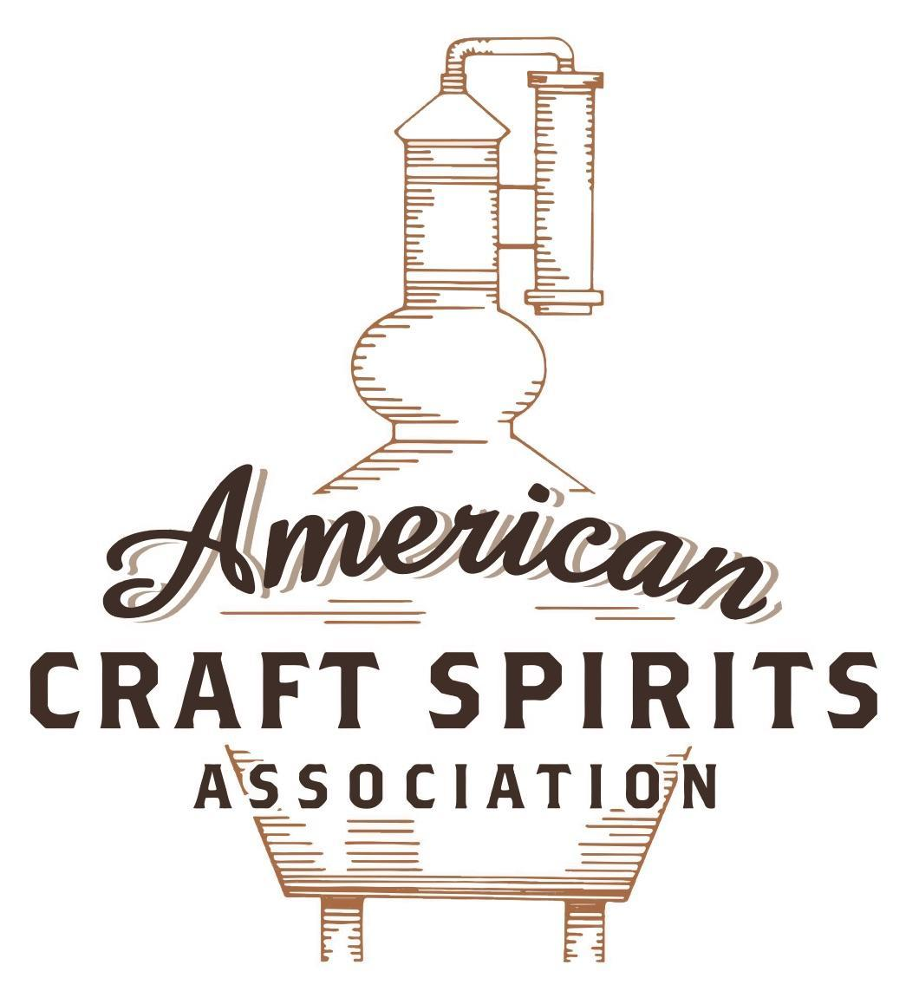
Spirits DtC Shipping Guide

This guide summarizes the direct-to-consumer shipping rules for distilleries in all 50 states and D.C. and also addresses the measures state governments have taken to ease delivery and shipping restrictions during the COVID-19 pandemic.

DtC Quick Guide Comparison

Out-of-State Distilleries  Can Ship Into State? |  |  |  | In-State Distilleries  Can Ship Within State?
State | Yes | No |  | State | Yes | No
AL |  | X |  | AL |  | X
AK | X |  |  | AK | X
AZ | X |  |  | AZ | X
AR |  | X |  | AR |  | X
CA |  | X* |  | CA |  | X*
CO |  | X |  | CO |  | X
CT |  | X* |  | CT |  | X
DE |  | X |  | DE |  | X
DC | X |  |  | DC | X
FL |  | X |  | FL |  | X
GA |  | X |  | GA |  | X
HI |  | X* |  | HI |  | ?*
ID |  | X |  | ID |  | X
IL |  | X* |  | IL |  | X*
IN |  | X |  | IN |  | X
IA |  | X* |  | IA |  | X*
KS |  | X |  | KS |  | X
KY | X |  |  | KY | X
LA |  | X |  | LA |  | X
ME |  | X* |  | ME |  | X*
MD |  | X |  | MD |  | X
MA |  | X |  | MA |  | X
MI |  | X |  | MI |  | X
MN |  | X |  | MN |  | X
MS |  | X |  | MS |  | X
MO |  | X |  | MO |  | X
MT |  | X |  | MT |  | X
NE | X |  |  | NE | X
NV |  | X* |  | NV |  | X
NH | X |  |  | NH |  | X*
NJ |  | X* |  | NJ |  | X*
NM |  | X |  | NM |  | X
NY |  | X* |  | NY |  | X*
NC |  | X |  | NC |  | X
ND | X |  |  | ND | X
OH |  | X |  | OH |  | X
OK |  | X |  | OK |  | X
OR |  | X |  | OR | X
PA |  | X* |  | PA |  | X
RI |  | X* |  | RI |  | X
SC |  | X |  | SC |  | X
SD |  | X |  | SD |  | X
TN |  | X |  | TN |  | X
TX |  | X |  | TX |  | X
UT |  | X |  | UT |  | X
VT |  | X |  | VT |  | X
VA |  | X |  | VA |  | X
WA |  | X* |  | WA | X
WV |  | X* |  | WV |  | X*

WI |  | X |  | WI |  | X
WY |  | X |  | WY |  | X

Notes:
*CA: If passed and signed into law, Senate Bill 620 would allow licensed distilled spirits producers in states other than California and licensed distilled spirits manufacturers or craft distillers in California who obtain distilled spirits direct shipper permits to ship directly to consumers in California
*CT: Consumers with appropriate permit may receive alcohol shipments
*HI: Consumers with appropriate permit may receive alcohol shipments; If passed and signed into law, Senate Bill 65 would allow licensed distilled spirits manufacturers in Hawaii and in states other than Hawaii who obtain direct shipper permits to ship directly to consumers in Hawaii
*IL: If passed and signed into law, Senate Bill 0532 would allow licensed distilled spirits producers in Illinois and in states other than Illinois who obtain distillery shippers’ licenses to ship directly to consumers in Illinois
*IA: If passed and signed into law, House File 639 would allow native distilled spirits manufacturers in Iowa and in states other than Iowa who obtain direct shipper permits to ship directly to consumers in Iowa and to consumers in states other than Iowa
*ME: If passed and signed into law, Legislative Document 1358 would allow distilleries outside of Maine with current manufacturer licenses and distilleries licensed in Maine who obtain spirits direct shipper licenses to ship directly to consumers in Maine
*NJ: (1) If passed and signed into law, Assembly Bill 3167 would allow a craft distillery licensees to ship no more than 9 liters of distilled spirits to a consumer in New Jersey; (2) If passed and signed into law, Senate Bill 3020 would allow craft distillery licensees in New Jersey or in states other than New Jersey to ship no more than 20 liters of distilled spirits to a consumer in New Jersey via common carrier
*NV: Licensed individuals can import one gallon per month of spirits for personal use and the out-of-state supplier must pay excise tax
*NH: If passed and signed into law, Senate Bill 125 would allow licensed liquor manufacturers who obtain direct to consumer shipping permits from the commission to ship directly to consumers in New Hampshire
*NY: Consumer may import up to 90L of liquor per year for personal use without a license; If passed and signed into law, Assembly Bill 3275 would allow licensed liquor manufacturers in states other than New York and licensed distillers and farm distillers in New York to ship no more than thirty-six cases (no more than nine liters per case) of liquor to consumers in New York
*PA: Consumer may place a special liquor order and distiller must ship to a PLCB-operated store
*RI: Distiller can only ship to customer if order was personally placed by customer at distiller's premises
*WA: If passed and signed into law, House Bill 1432 would allow licensed spirits manufacturers in states other than Washington to ship spirits to consumers in Washington
*WV: Distilleries, mini-distilleries, or micro-distilleries licensed in West Virginia or a state other than West Virginia who obtain private direct shipper licenses to ship to a consumer in West Virginia, however the shipments must be made to a retail liquor outlet

NORTH DAKOTA
Shipment Outbound – Yes (N.D. Cent. Code § 5-01-19).
Shipment Inbound – Yes, licensed direct shippers may sell 2.38 gallons or less of spirits per month to an individual for personal use and not for resale (N.D. Cent. Code § 5-01-16).
Shipment Intra-state – Yes, domestic distilleries may sell 2.38 gallons or less of spirits per month to an individual for personal use and not for resale (N.D. Cent. Code § 5-01-19).
COVID-19 Measures – North Dakota already allows distillers to ship directly to customers.
Citations (shipment)
North Dakota Century Code
§ 5-01-19. Domestic distillery.
2. A domestic distillery may sell spirits produced by that distillery at on sale or off sale, in retail lots, and not for resale, and may sell or direct ship its spirits to persons inside or outside the state in a manner consistent with the laws of the place of the sale or delivery in total quantities not in excess of twenty-five thousand gallons [94635 liters] in a calendar year. Direct sales within this state are limited to two and thirty-eight hundredths gallons [9 liters] or less per month per person for personal use and not for resale. The packaging must conform with the labeling requirements in section 5-01-16. … A domestic distillery may not engage in any wholesaling activities. Except as provided by section 5-01-19.1, all sales and deliveries of spirits to any other retail licensed premises in this state may be made only through a licensed North Dakota liquor wholesaler. However, a domestic distillery may sell distilled spirits to a domestic winery if the distilled spirits were produced from products provided to the domestic distillery by the domestic winery. No later than the last business day of a calendar month, a farm distillery that has made sales to a North Dakota wholesaler during the preceding calendar month shall file a report with the tax commissioner reporting those sales.
§ 5-01-16. Direct sale from out-of-state person to consumer – Penalty.
4.The alcoholic beverage transported in violation of this section and the vehicle used in violation of this section are forfeitable property under chapter 29-31.1.
5. This section does not apply to a transaction by a person holding a valid manufacturer's or retailer’s license issued by the state of its domicile and if the person obtains a direct shipping license from and on a form prescribed by the tax commissioner before making a shipment. The annual fee for a direct shipping license is fifty dollars. Licensed direct shippers may sell and ship to an individual twenty-one years of age or older 7.13 gallons [27 liters] or less of wine, two hundred eighty-eight fluid ounces [8517.18 milliliters] or less of beer, or 2.38 gallons [9 liters] or less of any other alcoholic beverages per month for personal use and not for resale.
a. A direct shipper shall ship all containers of alcoholic beverages shipped directly to a resident of this state using a licensed alcohol carrier and may cause the alcoholic beverages to be shipped by a licensed logistics company.
b. A direct shipper shall label all containers of alcoholic beverages shipped directly to an individual in this state with conspicuous words "SIGNATURE OF PERSON AGE 21 OR OLDER REQUIRED FOR DELIVERY".
c. A licensed direct shipper shall report and pay the wholesaler excise tax and retailer sales taxes to the tax commissioner on all alcoholic beverages sold to residents in this state at the rates set forth in sections 5-03-07 and 57-39.6-02. The excise tax reports are due January fifteenth of the year following the year sales and shipments were made. When the fifteenth day of January falls on a Saturday, Sunday, or legal holiday, the due date is the first working day thereafter. The report must provide such detail and be in format as prescribed by the tax commissioner and include the identification of any logistics or fulfillment houses the licensee used for such shipments. The sales and use tax reports are due as set forth in chapter 57-39.6. The sales and use tax reports must be in a format as prescribed by the tax commissioner. The tax commissioner may require that the report be submitted in an electronic format approved by the tax commissioner.
d. All alcoholic beverages that are shipped directly to a resident of this state must be properly registered with the federal alcohol and tobacco tax and trade bureau and must be owned by the licensed direct shipper.
6. A licensed alcohol carrier may ship alcoholic beverages into, out of, or within this state. A licensed alcohol carrier shall pay an annual fee of one hundred dollars and obtain a license on an application form provided by the tax commissioner and subject to any requirements determined by the tax commissioner.
a. A licensed alcohol carrier shall ensure all containers of alcoholic beverages shipped directly to an individual in this state are labeled with conspicuous words "SIGNATURE OF PERSON AGE 21 OR OLDER REQUIRED FOR DELIVERY". A licensed alcohol carrier may not deliver alcoholic beverages to a person under twenty-one years of age, or to a person who is or appears to be in an intoxicated state or condition. A licensed alcohol carrier shall obtain valid proof of identity and age before delivery and shall obtain the signature of an adult as a condition of delivery.
b. A licensed alcohol carrier shall maintain records of alcoholic beverages shipped into, out of, or within this state which include the name of the licensed direct shipper, the name of any licensed logistics shipper, the date of each shipment, the recipient’s name and address, and an electronic or paper form of signature from the recipient of the alcoholic beverages. A licensed alcohol carrier shall submit a report to the tax commissioner on a monthly basis in the form and format prescribed by the tax commissioner. The report is due on the last day of the month following the month of shipment. If the due date falls on a Saturday, Sunday, or legal holiday, the due date is the first working day after the due date. The tax commissioner may require that the report be submitted in an electronic format approved by the tax commissioner.
c. If the tax commissioner has provided notice to a licensed alcohol carrier that a direct shipper is not licensed, the licensed alcohol carrier must notify the direct shipper that the direct shipper must obtain a direct shipper permit before tendering packages to the licensed alcohol carrier for delivery. Any assessed penalty may be waived by the tax commissioner for good cause upon request by the licensed alcohol carrier.
7.Licensed logistics shippers must obtain a logistics shipping license from the tax commissioner and shall pay an annual fee of one hundred dollars before making or causing a shipment.
a. A licensed logistics shipper shall ensure all containers of alcoholic beverages shipped directly to an individual in this state are labeled with conspicuous words "SIGNATURE OF PERSON AGE 21 OR OLDER REQUIRED FOR DELIVERY".
b. All containers of alcoholic beverage shipped directly to a resident of this state must be shipped using a licensed alcohol carrier as provided in subsection 6.
c. A licensed logistics shipper shall maintain records of alcoholic beverages shipped which include the license number and name of the licensed direct shipper, the license number and name of the licensed common carrier, the date of each shipment, the quantity and kind of alcohol shipped, and the recipient's name and address for each shipment. A licensed logistics shipper shall submit a report to the tax commissioner on a monthly basis in the form and format prescribed by the tax commissioner. The report is due on the last day of the month following the month of shipment. If the due date falls on a Saturday, Sunday, or legal holiday, the due date is the first working day after the due date. The tax commissioner may require that the report be submitted in an electronic format approved by the tax commissioner.
d. Licensed logistics shippers may not ship alcoholic beverages from unlicensed direct shippers or through unlicensed carriers. For a violation, a licensed logistics shipper is subject to the penalties in subsection 3.
8. The tax commissioner may initiate and maintain an action in a court of competent jurisdiction to enjoin a violation of this section and may request award of all costs and attorney's fees incurred by the state incidental to that action. Upon determination by the tax commissioner that an illegal sale or shipment of alcoholic beverages has been made to a consumer in this state by any person, the tax commissioner may notify both the alcohol and tobacco tax and trade bureau of the United States department of the treasury and the licensing authority for the state in which the person is domiciled that a state law pertaining to the regulation of alcoholic beverages has been violated and may request those agencies to take appropriate action.

Link to Chapter 5-01: https://www.legis.nd.gov/cencode/t05c01.pdf#nameddest=5-01-19

The American Craft Spirits Association (ACSA) is working diligently to give our members and industry partners relevant, current updates on statutes and regulations impacting production, sale and distribution of spirits. With the declaration of the novel coronavirus (COVID-19) in early 2020, many states have issued temporary policy changes or longer-term modernization of alcohol beverage laws. State statutes, regulations created by the state alcohol regulatory authority, as well as any other relevant guidance provided by such authorities (such as advisories, opinions, bulletins, etc.) were reviewed in creation of this document. No city or county ordinances were reviewed. Distillers should be aware that even in states where direct shipping is permissible, always remember to avoid shipping to dry counties. Please consult with your state guild or alcohol beverage authority for the most up-to-date information. This content is intended for educational and informational purposes only. ACSA's pro bono law firm of Malkin Law P.A. provided the core content found in this comprehensive overview of the spirits distribution after COVID-19. It was completed in August 2021 and will be updated regularly. If you have updates you would like to provide, please send to legislation@americancraftspirits.org or directly to the law firm at: ryan@malkin.law / malkin.law. Thank you.

